**Using the Monerujo Android Wallet**

Monerujo is an open-source android wallet. You will restore an account on mobile, which is similar to restoring an account on desktop, and then you will send Monero between these two accounts.

Start off by downloading the Monerujo application. You can download it by searching for it on the Google Play Store or by visiting the website here: monerujo.io. Enroll for the beta if possible to get the latest updates.

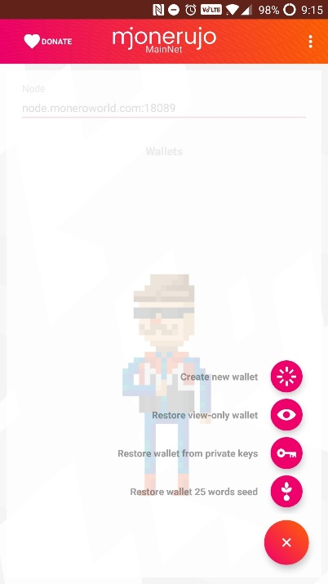 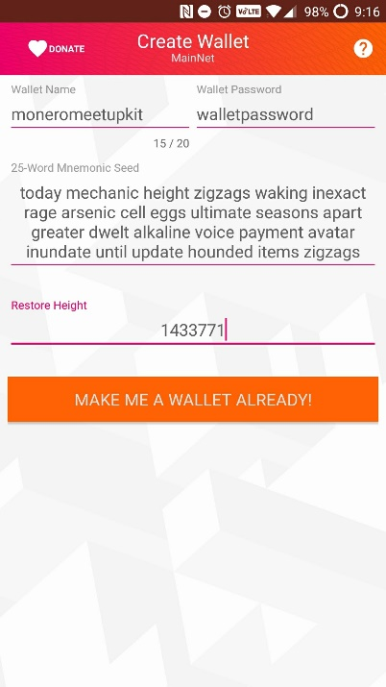 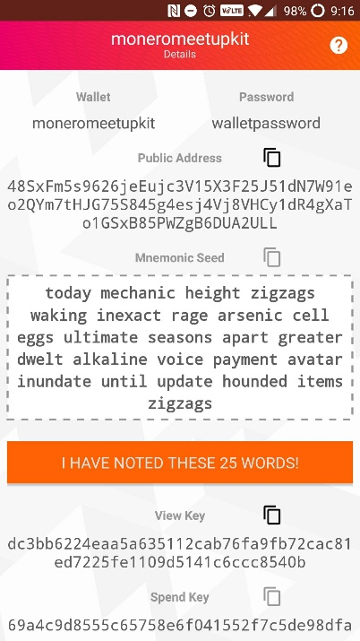 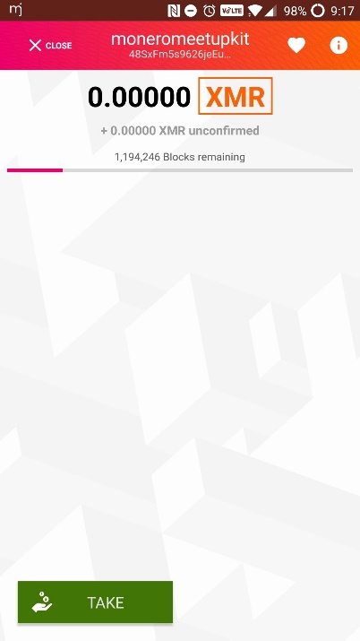

Open the application; verify that “node.moneroworld.com:18089” is the node. Fill it in manually if needed.

Click the plus button in the lower right corner. Then click on the restore from seed option.

Create a wallet name of your choosing, create a password, type in the 25-word mnemonic seed of a DIFFERENT paper wallet than you used before, and add the restore height of 1440000. If you do not do this last part, it will take a very long time to sync the blocks. Then click on the button to create your wallet.

It will show some info. Proceed, since you already have the mnemonic seed written on the paper wallet.

Your wallet will synchronize with the network. It should only take a few seconds if you specified a restore height. You can check the status on the top progress bar. It is ready when the option to “give” appears.

**Sending Monero (Android to Desktop)**

Sending Monero is simple, regardless what device you are using. This guide will cover how to send Monero from the phone to the desktop wallet and back.

Click on the “give” button. It will show the send screen. On the desktop client, click on the “receive” tab. On the phone, use the scan button and scan the QR code of the desktop wallet.

Then add the amount you would like to send. In the mobile wallet only, it can look up the equivalent value in USD or EUR. You can change the currency by pressing on “XMR”. In this example, let’s send the equivalent of $1 to the desktop wallet. Press on “XMR”, select USD, and add 1 to the amount field.

Don’t bother changing the advanced settings. You can leave them be. Don’t add a payment ID either.

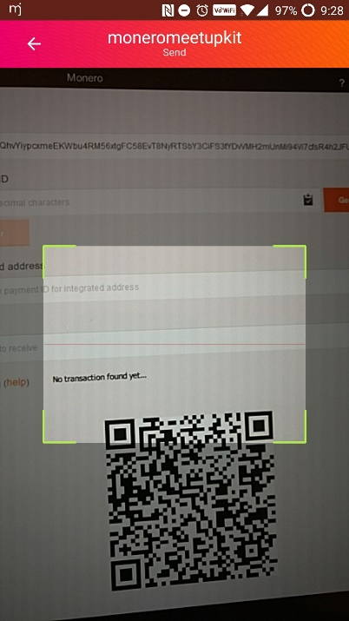 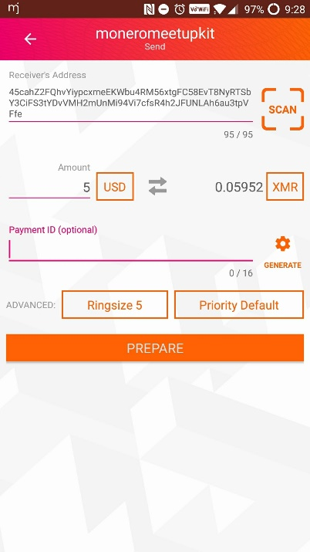

Click on prepare and confirm the transaction. It should show up on your desktop wallet shortly! Congrats! Check the desktop history tab. It will show up as locked balance until it has enough confirmations for you to spend it again. This will take a few minutes.

**Sending Monero (Desktop to Android)**

Now let’s send Monero from the desktop wallet to the android wallet. This is unfortunately clumsy, since there is no simple way to scan a QR code on the desktop.

On android, click on “take” this time. The screen will show you the public address. You need to copy this public address and paste it on the desktop computer, or type it in manually. I highly suggest sending yourself a message instead of trying to type it, but it’s still possible to do manually!

On desktop, go to the “send” tab. Put the android address in the “address” field. Choose an amount (remember, in XMR, not in USD/EUR/etc!) and write yourself a personal description if desired. For simplicity, you can click the “All” button. This description is stored locally and is not shown to anyone else, including the receiver.

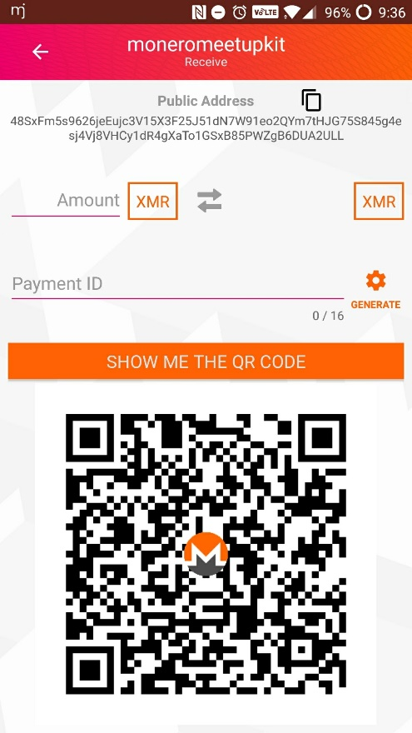 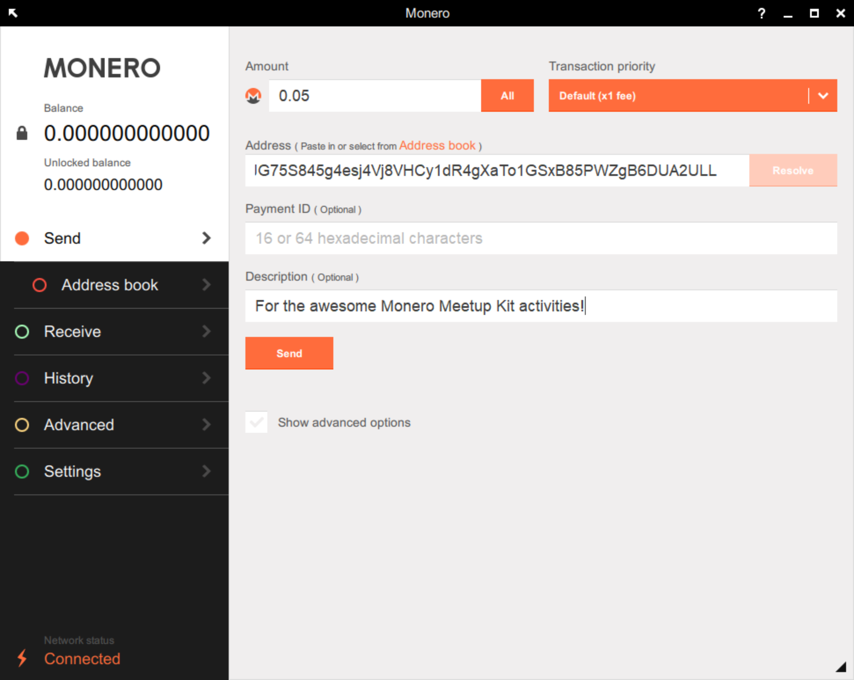

Click on “send”, then confirm when the popup window appears. You have successfully sent Monero from the desktop wallet to the android wallet! You will again need to wait some time for this transaction to become unlocked and spendable again.

**Sending Monero (Android to Android)**

You should have a hang of this now! Try sending Monero between android devices. This is easy, since phones support scanning QR codes.

Unfortunately, there is currently not reputable iOS application available yet, though several are in development. Please do not use Freewallet, which is deemed untrusted by the community. They store your funds for you, which means they could “accidentally” lose your Monero at any time and there’s no way for you to get them back. With Monerujo, you have control over your keys and seed.

Please take all the money off these accounts after you are done with these activities and never use them again. Since someone else may have recorded the mnemonic seed, they can restore the account and take back any money left on or sent to these accounts.